CMP6200/DIG6200

Individual Undergraduate Project 2024–2025

**A1: Proposal**

Gamifying movements BENEFICIAL for upper limb stroke rehabilitation



Course: Computer Games Technology

Student Name: James Richard Bland

Student Number: 22142846

Supervisor Name: Xi Guo

Contents

1 Introduction 1

1.1 Background and Rationale 1

1.2 Key Themes/Topics 1

2 Project Planning 2

2.1 Initial Project Plan 2

2.2 Resources 3

2.3 Risk Assessments 4

3 Project Review and Methodology 4

3.1 Critique of Past Final Year Projects 4

# Introduction

## Background and Rationale

Upper limb stroke rehabilitation typically sees heightened implementation after patients are discharged from the hospital. After returning home a patient should undertake home therapy programmes to further recover and better their quality of life.

Having a range of home therapy options is vital, crucially due to patient travel limitations. Almost 10 million people in England live in rural areas. (Gov.Uk, 2024:7) In these areas there are more people aged 50-59 years than any other age group with one in four people being over 65 (Gov.Uk, 2024:8). This correlates with the ages statistically vulnerable to having a stroke. According to the GRASP instructor manual (The University of British Columbia, 2021:9) the risk of stroke doubles every 10 years after age 55, with the typical age at the time of stroke being 70 – 75 and 25% of strokes occurring in individuals below the age of 65.

The brain has the most ability to repair itself in the first 3 months’ post stroke (The University of British Columbia: 2021: 5) therefore it is vital that the patient completes as much therapy in this time as possible to maximise recovery. Currently there are home therapy programmes such as the GRASP manual. However contemporary home therapy programmes do not provide high levels of motivation to the patient, this can cause the therapy to be neglected leading to sub-optimal recovery or potentially other implications such as learned non-use syndrome (The University of British Columbia, 2021: 13).

Therefore, it is important to explore ways to provide more motivation to the patient. Gamification and even more so multiplayer gamification is one such way this goal can be achieved. Being able to play the game alongside family members, friends or caregivers may provide higher levels of motivation and reduce the neglect of home therapy, increasing its effectiveness.

This paper is the first stage of the experiment and will be tested on healthy adults to verify the intended movements are being performed in the correct repetition ranges and to test the user experience and motivation using the game.

## Key Themes/Topics

Key Words:

* Games for rehabilitation – The design decisions made for the artefact will be made through the lens of providing effective rehabilitation
* Upper extremity – arm, wrist and hand movement and flexion will be targeted
* Stroke
* Multi-player – multiplayer games often cause a game to have increased replay ability which is vital for a rehabilitation game as it will be used very frequently
* Gamification – Gamification will be employed to create a therapy which gives the user greater motivation to use the therapy.

Key Themes:

* Production of a gamified treatment to encourage beneficial movements
* Game design, especially game design pertaining to serious games and stroke rehabilitation
* User centred design
* Multiplayer game design
* Motivation and willingness to use the game created

# Project Planning

## Initial Project Plan

An Agile methodology specifically scrum will be used during development. At a high level there will be a planning phase, followed by implementation and then evaluation. In the planning phase the different requirements of the project will be considered to create an exhaustive list of tasks which need to be completed.

Then the implementation phase will be split into three cycles, the exhaustive list from the previous phase will be used to plan what work will be completed in the next cycle. After the second cycle a pilot test will be conducted, and the third cycle will address issues found.

Finally, once the project is complete it can be tested and its effectiveness evaluated.

Table 1 below outlines the tasks which will need to be completed for the project.

Table 1 high level tasks to complete

|  |  |  |  |
| --- | --- | --- | --- |
| Task Name | Task Description | Date Start | Date End |
| Research into existing systems (Literature review) | Research looking at conventional therapy options and what movements/exercises they use. Additionally, investigation into game design of upper limb rehabilitation serious games will be conducted | 12/10/2024 | 25/11/2024 |
| Use research to design game | A small design document will be produced. Additionally, an exhaustive task list will be created. Each task having a cost and priority ranked 1 – 3 break each task down into its atomic elements | 25/11/2024 | 05/12/2024 |
| Design interaction | This will require consideration to be taken into how the user will interact with the game, utilizing etee controllers, in a simple and effective way. | 25/11/2024 | 05/12/2024 |
| Game menu and flow design | What menus will be present in the game will be designed as well as the flow of using the system. | 25/11/2024 | 05/12/2024 |
| Game loop design | Design in the moment-to-moment gameplay will be considered | 25/11/2024 | 05/12/2024 |
| Meta game design | This design focuses on the gameplay of an entire game/ play session | 25/11/2024 | 05/12/2024 |
| Sound design | What sounds will be needed | 25/11/2024 | 05/12/2024 |
| UI design | Each menu and UI will have to be designed. | 25/11/2024 | 05/12/2024 |
| Development cycle 1 | Development cycle 1 will consist of setting up the multiplayer and etee controls. Basic menus and placeholder UI will be created. A prototype White box level will be created along with some simple interaction. | 10/12/2024 | 25/12/2024 |
| Development cycle 2 | The gameplay will be completed in this phase. Game interaction will be continuously tested for ease of use. 3d art will be added to the game. | 25/12/2024 | 15/01/2025 |
| Prototype testing | The prototype will be tested to see if users can use the game easily and if it is encouraging the movements intended | 15/01/2025 | 25/01/2025 |
| Development cycle 3 | The final phase of development will be dedicated to polishing the game, this includes responding to tester feedback, adding in art, sound effects and complete menus. | 10/02/2025 | 15/03/2025 |
| Plan for testing of the effectiveness of the game | Time will need to be taken to consider how the testing will be conducted and preparing resources for the testing such as printing off resources such as how to use the controllers, how to play the game etc… | 25/11/2024 | 10/12/2024 |
| Testing the effectiveness of the game | The actual testing of the game will look to gather adult participants to test the game. The success of the project can then be evaluated. | 15/03/2025 | 28/04/2025 |

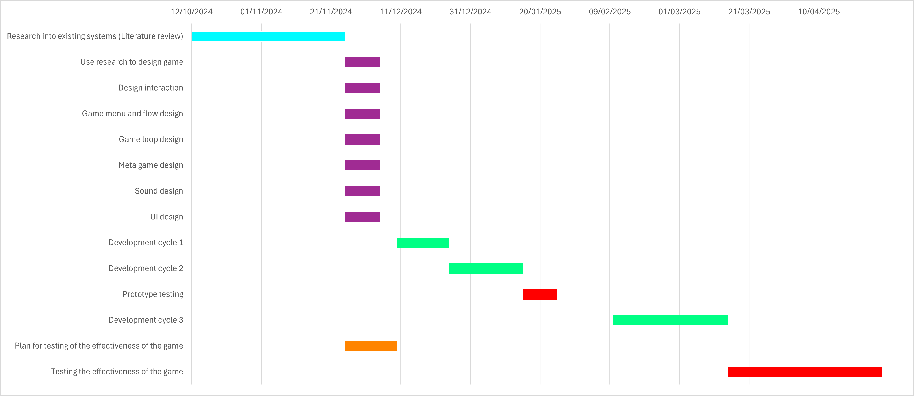Figure 1 tasks to complete visualised as a Gantt Chart

## Resources

* Computer (with internet connection), mouse and keyboard
* Access to someone knowledgeable in the field of upper limb stroke rehabilitation
* Unity game engine
* Version/source management software (GitHub)
* An integrated development environment (IDE) such as JetBrains Rider
* Access to adults with a varying prior experience with videogames for the final testing
* Home stroke rehabilitation items currently being used to compare the project artefact to
* A pair of etee controllers for development, testing and playing the game
* Access to someone knowledgeable with unity in case implementation issues and bugs arise
* Information such as the grasp manual to identify beneficial movements and/or exercises
* New people to playtest the game during development to check for quality, fun and usability
* Access to copyright free music and sound effects to put into the game
* Access to copyright free art assets to use in the game
* Software to create art assets when needed for the game (visual and auditory)
* Word for creating design and planning documents
* Access to a printer to print off resources such as guides on how to play the game/the structure of the testing session to be shown to participants in testing.

## Risk Assessments

|  |  |  |  |
| --- | --- | --- | --- |
| Risk assessment issue | How it will be mitigated | Likeliness (1-3) | Severity (1-3) |
| Hygiene issues | Antiseptic wipes | 3 | 1 |
| Controller damage | Controllers will be transported in their original packaging. | 2 | 3 |
| Hardware issues | GitHub source control and computer transport bag | 2 | 2 |
| Limited access to field specialists | Information will mostly be gathered independently. | 3 | 1 |
| Inexperience using unity networking solution | Unity has very good documentation and community to aid learning. | 3 | 2 |
| First time developing using etee API | Reaching out to members/developers at etee for support if issues arise. | 3 | 2 |
| No access to contemporary home therapy equipment | Use non equipment therapies to compare against for user motivation. | 3 | 1 |
| Implementation issues | Tasks will be well planned and broken down. This will allow the scope of the project to be realistic at conception and will allow the scope to be intelligently adjusted to ensure the project finishes on time. | 3 | 2 |
| Unable to access or create art assets for the game | By keeping the game world small the art assets required are limited decreasing the probability of missing assets. | 2 | 2 |
| Use of copyright material | Any third-party assets will be checked for copyright. | 3 | 3 |
| External responsibilities (work and other modules) | Same as implementation issues. | 3 | 3 |

# Project Review and Methodology

## Critique of Past Final Year Projects

(Goff, 2020) starts his paper by acknowledging the current issue of global warming and environmental damage. Goff (2020: 9) asserts “The tourism/travel industry is a significant contributor to worldwide pollution”. The project produces a mobile application to be part of a solution to this problem. The application is designed to gamify tourism in a way that encourages walking to destinations rather than taking a car or bus. This is done using gamification techniques such as, statistics (score, steps, landmarks visited, routes, distance travelled and time spent), awards and a level attached to the account. These are effective gamification techniques. In the evaluation Goff (2020:38) remarks that according to feedback obtained through questionnaires these techniques were effective and lead to more engagement in the experiment group.

Goff’s (2020) project is relevant to this one as it employs gamification techniques to encourage certain behaviours. In this case using sustainable travel. Gamification in the design of this project should be considered to drive user motivation.

To critique this project, the decision to develop the application for IOS systems was a large risk. Goff (2020: 12-13) had little experience developing for iOS and its multitude of difficulties. It was later remarked in the challenges and issue’s part that “The most significant issue during the project was underestimating the time needed to learn the new system and programming language being used to develop the artefact” (Goff, 2020: 21). This led to features not being completed. Taking these lessons learnt and applying them to this project means that Unity, a familiar game engine, will be used to develop the project. This will help reduce the time spent learning and troubleshooting new technologies. One of the reasons this learning process was such a hindrance was the lack of documentation and guidance. (Goff, 2020:21) Fortunately, programmers at etee will be able to answer questions regarding the API for development with etee controllers.

(Day, 2018) seeks to examine the efficacy of the use of VRET when used to treat anxiety disorders, specifically public speaking. Day (2018) recognises the studied effectiveness of exposure therapy as a treatment for irrational fears and positions this paper to be an extension of that knowledge. Achieve the aim of the project a bespoke environment was produced to mean VRET standards. The project overall met its objectives. As for the efficacy of the system the test showed “The results of the experiments show that participants who performed the interview within VR showed a greater decline in heartrate by the end of the mock interview than those who performed outside VR” (Day, 2018:52) therefore the system was deemed as overall effective.

This paper is linked to this project as it details the development of a serious game designed to be used as a treatment.

One thing that was done very well was the effective use of a user centred design methodology. This manifested itself as a set of playtests. The first playtest uncovered a negative response to the environment created. With testers reporting of an uncanny valley feeling. After receiving this feedback Day (2018) was able to make the appropriate changes to the environment such that the testers no longer felt that the environment was distracting.

However, due to the nature of the project some complex ethical considerations must be made. This would have increased the complexity of the project. Considerations must be made regarding exposing users to a VRET environment and considerations into the wellbeing of users with diagnosed social anxiety disorder included in the study. For reasons like those previously described this paper will focus on nondescript adults.